**Answer Sheet**

**Online Assignement-1**

|  |  |  |  |  |  |  |  |  |  |
| --- | --- | --- | --- | --- | --- | --- | --- | --- | --- |
| **Course Code:** | **CAP 276** | | | **Course Title:** | | **Data Communication and Networking-Laboratory** | | | |
| **Course Instructor: Avinash Bhagat** | | | | | | | | | |
| **Student’s Roll no:** | | **RD2112A103** | | | | **Student’s Reg. no:** | | **12111670** | |
| **Name: Jayshri Lal Pandit** | | | | | | | | | |
| **Set Assigned (Tick):** | | | **B** | | **Page No.** | | **1** | **Total Pages** | **3** |

1. **Objective** (Description of the practical to be performed)**:**

We have to design a network topology with a Star backbone connected Bus, Ring and Mesh topologies. Every topology have four hosts in it*.* A topology is used to explain how a network is physically connected and the logical flow of information in the network. A topology mainly describes how devices are connected and interact with each other using communication links.

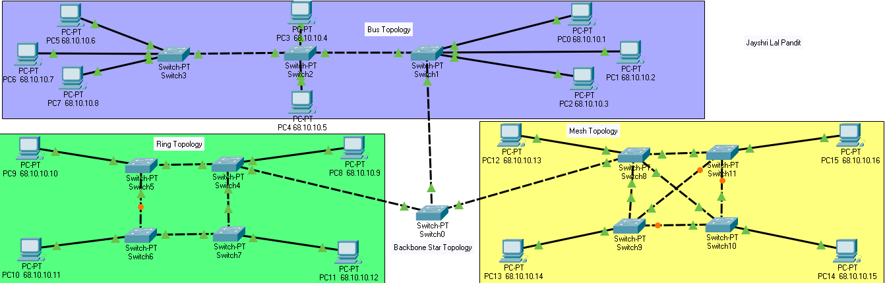 **2. Network Snapshot with proper labelling:**

|  |  |  |  |  |  |  |  |  |  |
| --- | --- | --- | --- | --- | --- | --- | --- | --- | --- |
| **Course Code:** | **CAP 276** | | | **Course Title:** | | **Data Communication and Networking-Laboratory** | | | |
| **Course Instructor: Avinash Bhagat** | | | | | | | | | |
| **Student’s Roll no:** | | **RD2112A103** | | | | **Student’s Reg. no:** | | **12111670** | |
| **Name: Jayshri Lal Pandit** | | | | | | | | | |
| **Set Assigned (Tick):** | | | **B** | | **Page No.** | | **2** | **Total Pages** | **3** |

**3. Initial IP Configuration:**

|  |  |  |  |
| --- | --- | --- | --- |
| **Device** | **Interface** | **IP Configuration** | **Connected with** |
| **PC0** | **Fa0** | **68.10.10.1** | **Switch1** |
| **PC1** | **Fa0** | **68.10.10.2** | **Switch1** |
| **PC2** | **Fa0** | **68.10.10.3** | **Switch1** |
| **PC3** | **Fa0** | **68.10.10.4** | **Switch2** |
| **PC4** | **Fa0** | **68.10.10.5** | **Switch2** |
| **PC5** | **Fa0** | **68.10.10.6** | **Switch3** |
| **PC6** | **Fa0** | **68.10.10.7** | **Switch3** |
| **PC7** | **Fa0** | **68.10.10.8** | **Switch3** |
| **PC8** | **Fa0** | **68.10.10.9** | **Switch4** |
| **PC9** | **Fa0** | **68.10.10.10** | **Switch5** |
| **PC10** | **Fa0** | **68.10.10.11** | **Switch6** |
| **PC11** | **Fa0** | **68.10.10.12** | **Swtich7** |
| **PC12** | **Fa0** | **68.10.10.13** | **Swtich8** |
| **PC13** | **Fa0** | **68.10.10.14** | **Switch9** |
| **PC14** | **Fa0** | **68.10.10.15** | **Switch10** |
| **PC15** | **Fa0** | **68.10.10.16** | **Switch11** |
| **Switch0** | **Fa0/1,Fa1/1,Fa2/1** | **--------------------------------** | **Switch1,Switch4,Switch8** |
| **Switch1** | **Fa0/1,Fa1/1,Fa2/1,Fa3/1** | **--------------------------------** | **Switch0,Switch2** |
| **Switch2** | **Fa0/1,Fa1/1,Fa2/1,Fa3/1** | **--------------------------------** | **Switch3,Switch2** |
| **Switch3** | **Fa0/1,Fa1/1,Fa2/1,Fa3/1** | **--------------------------------** | **Switch2** |
| **Switch4** | **Fa0/1,Fa1/1,Fa2/1,Fa3/1** | **--------------------------------** | **Switch5,Switch7** |
| **Switch5** | **Fa0/1,Fa1/1,Fa2/1** | **--------------------------------** | **Switch4,Switch6** |
| **Switch6** | **Fa0/1,Fa1/1,Fa2/1** | **--------------------------------** | **Switch5,Switch7** |
| **Switch7** | **Fa0/1,Fa1/1,Fa2/1** | **--------------------------------** | **Switch6,Swich4** |
| **Switch8** | **Fa0/1,Fa1/1,Fa2/1,Fa3/1** | **--------------------------------** | **Switch9,Switch11** |
| **Switch9** | **Fa0/1,Fa1/1,Fa2/1,Fa3/1** | **--------------------------------** | **Switch8,Switch12** |
| **Switch10** | **Fa0/1,Fa1/1,Fa2/1,Fa3/1** | **--------------------------------** | **Swich9,Switch11** |
| **Switch11** | **Fa0/1,Fa1/1,Fa2/1,Fa3/1** | **--------------------------------** | **Switch8,Switch10** |
|  |  |  |  |

|  |  |  |  |  |  |  |  |  |  |
| --- | --- | --- | --- | --- | --- | --- | --- | --- | --- |
| **Course Code:** | **CAP 276** | | | **Course Title:** | | **Data Communication and Networking-Laboratory** | | | |
| **Course Instructor: Avinash Bhagat** | | | | | | | | | |
| **Student’s Roll no:** | | **RD2112A103** | | | | **Student’s Reg. no:** | | **12111670** | |
| **Name: Jayshri Lal Pandit** | | | | | | | | | |
| **Set Assigned (Tick):** | | | **B** | | **Page No.** | | **3** | **Total Pages** | **3** |

**4. Process Description:**

**Step-1:** Create Bas topology using Switches and connect minimum four host in it.

**Step-2:** Create Ring topology using Switches and connect some hostsin it**.**

**Step-3:** Create Mesh topology using Switches and connect some hosts init.

**Step-4:** Connect above three topology to the Star backbone topology**.**

**Step-5:** After above task we have to assign all topology hosts with IP addresses.